**Big Data Assignment 1**

1. Which province shows you maximum orders and what is the ‘exact’ number of orders for this province?

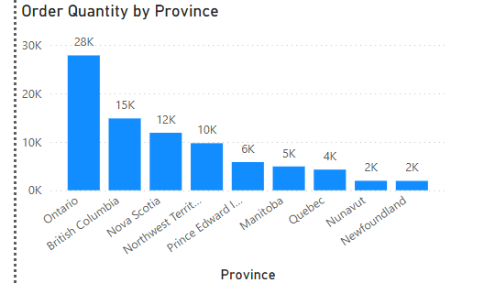

Ontario has the highest number of orders with a total of 27,840 orders.

1. Which customer had the maximum sales? Specify Name and exact sales amount?

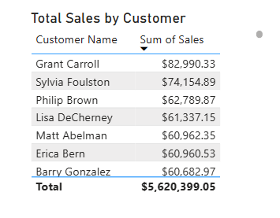

Out of all customers, Grant Caroll had the maximum sales with a total of $82,990.33.

1. Which province has the maximum sales and what is the exact amount of the sales?

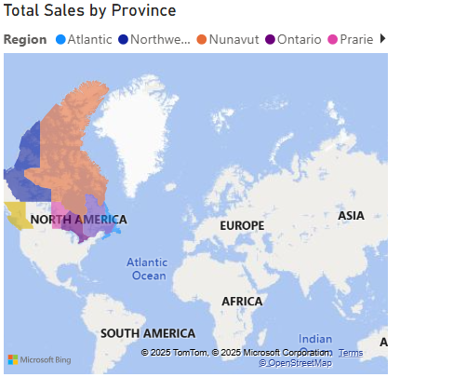

Contrary to land mass, the province with the maximum sales is Ontario, with total sales of $1,748,758.22.

1. Which year had the maximum order quantity and what was the exact number of orders?

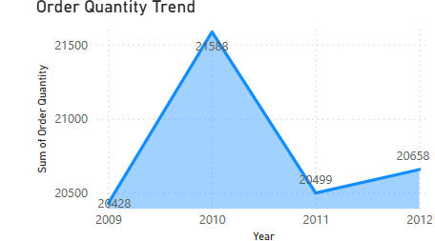

The trend shows that the maximum order quantity of 21,588 was placed in 2010.

1. Your choice of another meaningful visualization and an insight.

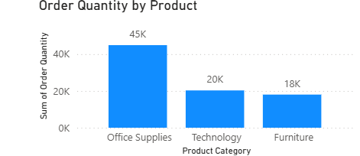

This bar chart illustrates that over the duration the data was collected, office supplies were sold the most, with 45,000 total orders.

1. Your choice of another meaningful visualization and an insight.

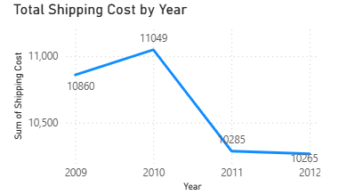

This graph shows that 2010 has the highest total shipping cost, which aligns with the fact that 2010 had the highest order quantity.

1. Completed Dashboard

